**Lesson 1 – Tutorial**

1. Create the following HTML documents.

**Home.html**

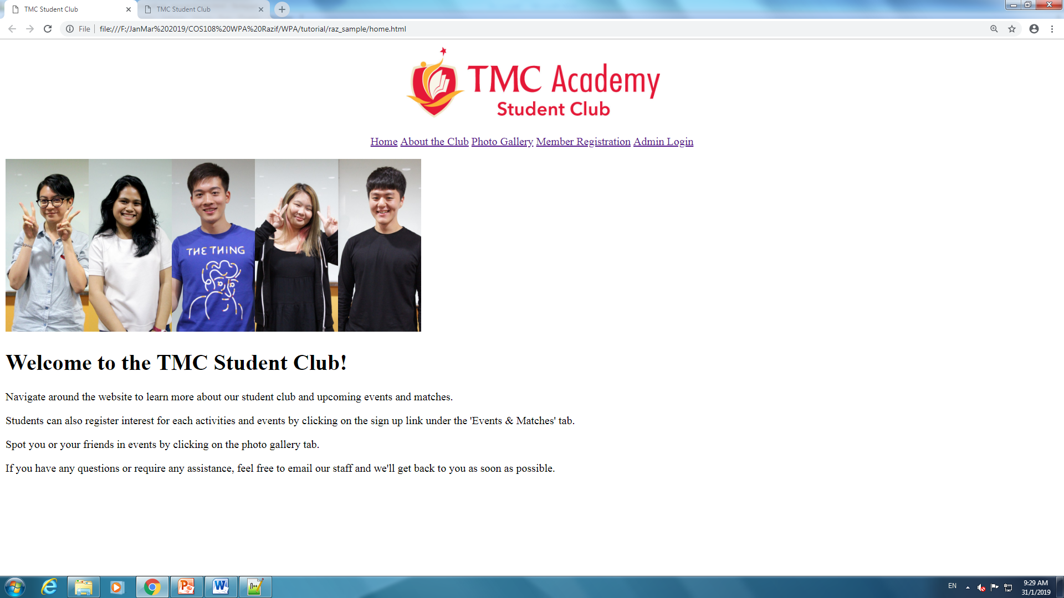

**About.html**

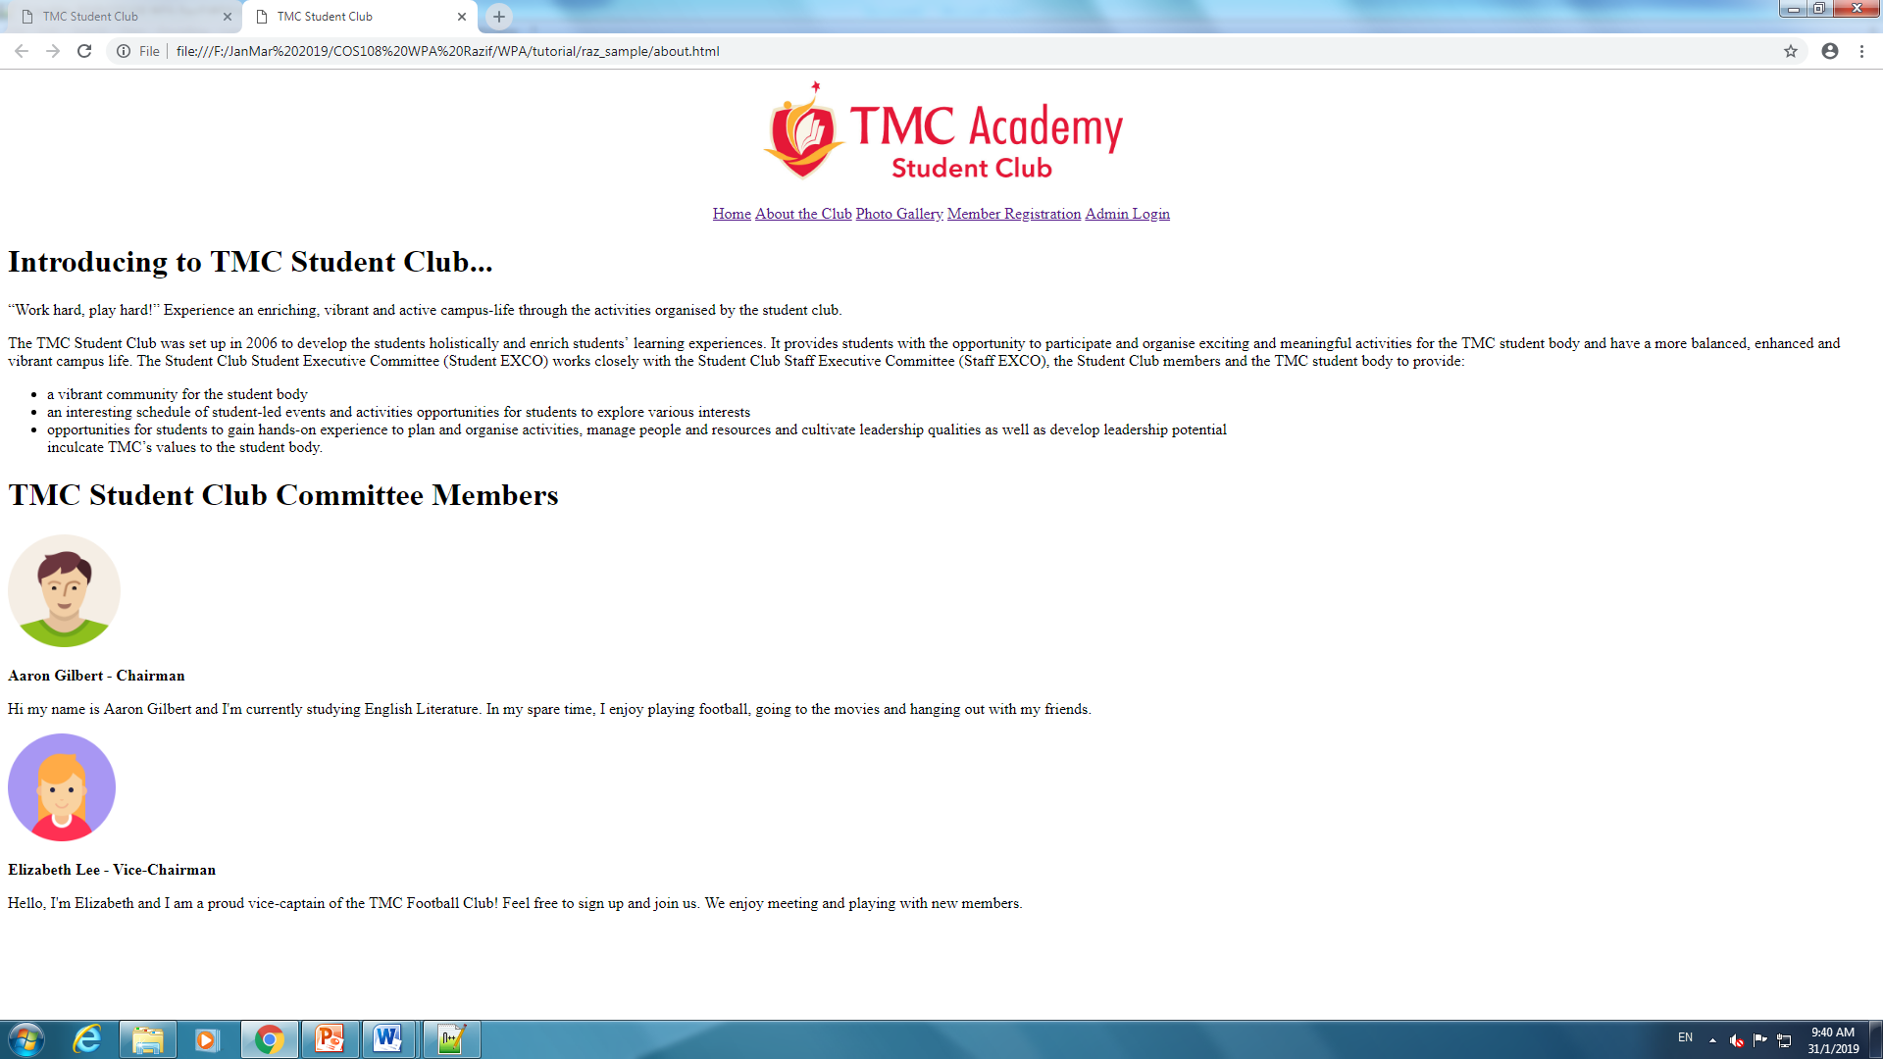

**Photo.html**

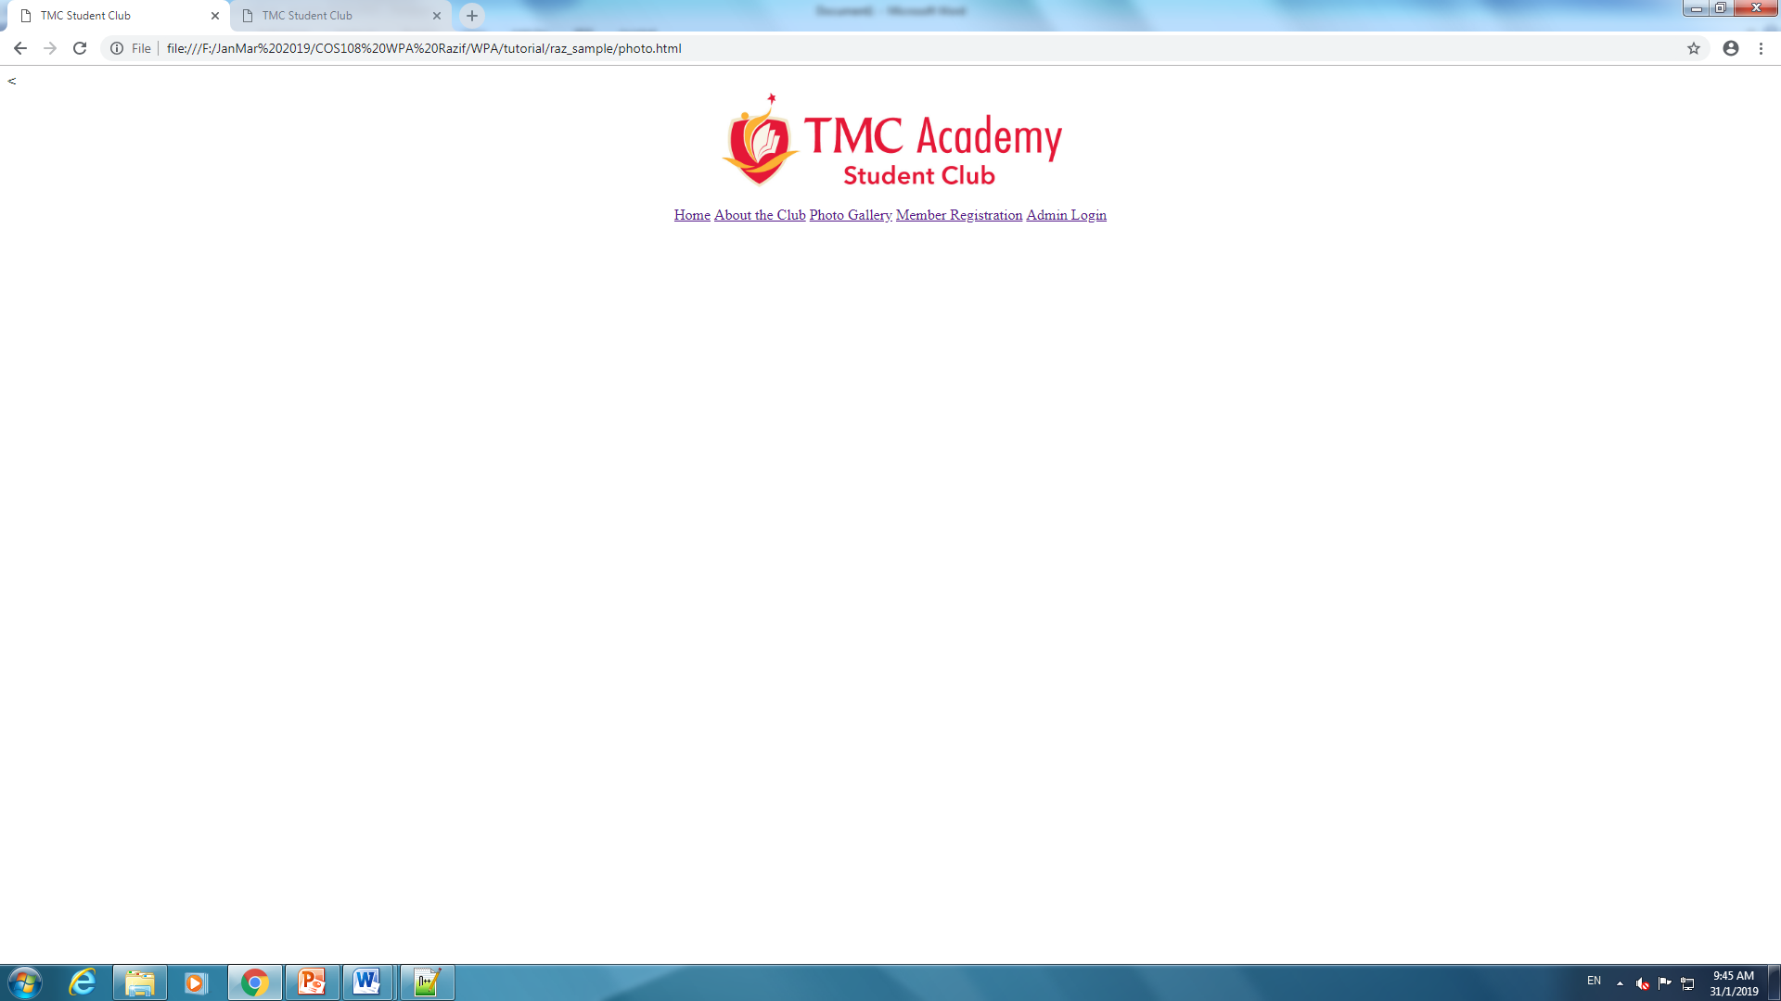

**Registration.html**



**Login.html**

